206 Road to Reading Log
Each time your child turns in a completed reading log, they will move along the Road to Reading in our classroom! Each time they reach the Library they get to go to the prize box!

Name: _______________________________________________________________________________

Start Date: _________________________________ End Date: _________________________________

Read by  Student  Easy, Hard, etc. | Read by Someone Else  Interested, bored, etc. | Title | Date
 |  | 1.
 |  | 2.
 |  | 3.
 |  | 4.
 |  | 5.
 |  | 6.
 |  | 7.
 |  | 8.
 |  | 9.
 |  | 10.

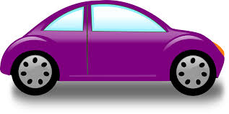
COMMENTS:

