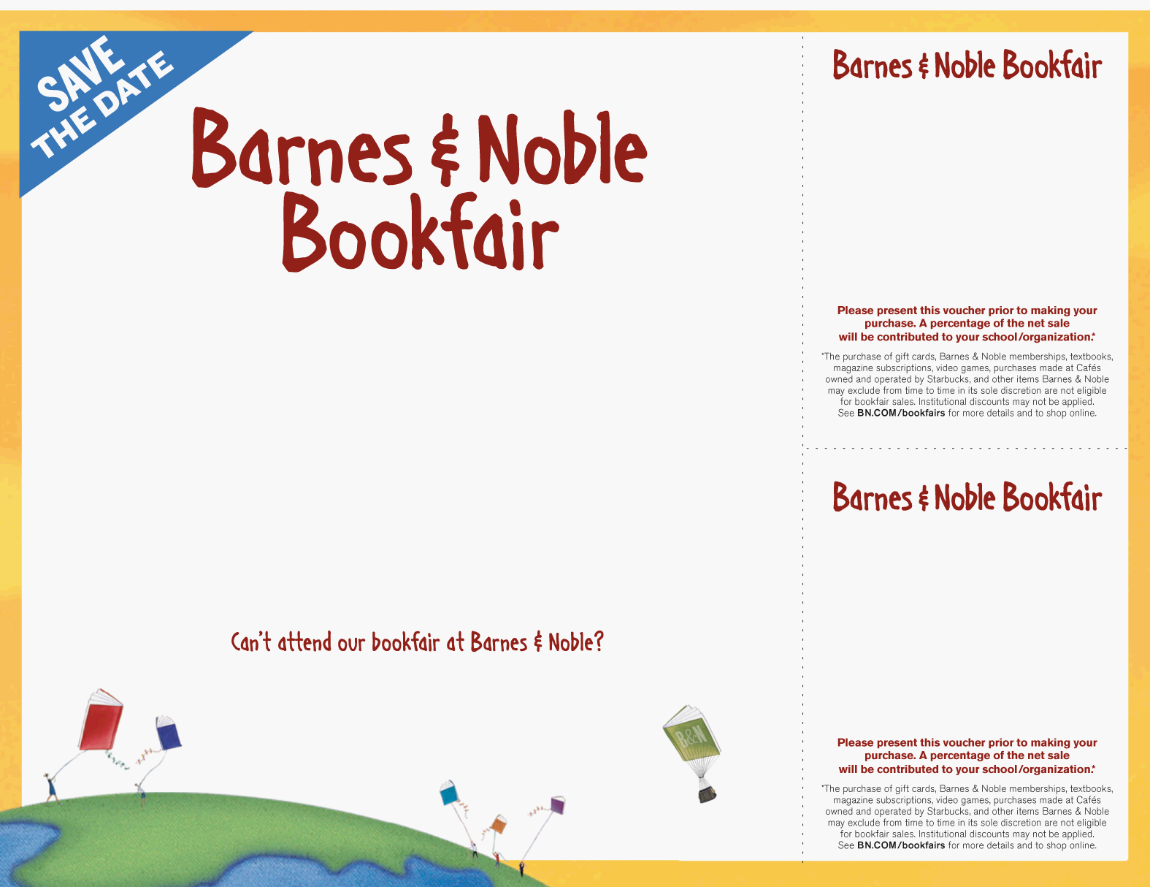
Thursday, February 5, 2015 from 5pm to 8pm
Barnes & Noble – Mira Mesa Blvd.

Join us for the following:
- Tour our “Celebration of the Arts” art show, featuring work by EBS students
- Watch performances by our school choir, band and orchestra
- Get your picture taken with Penny, the Wonder Dog!
- Lots of fun activities for kids, including cupcake decorating and a scavenger hunt

Events Schedule:
5:30 – 6:00 – Pictures with Penny
5:30 – Choir Performance
6:00 – Orchestra Performance
6:30 – Choir Performance
7:00 – Band Performance

Visit BN.COM/bookfairs to support us
online from 2/5/15 to 2/13/15 by entering
Bookfair ID 11526134 at checkout.

Help us support
EBS Elementary
Thursday, Feb. 5, 2015: 5pm - 8pm

Barnes & Noble
Mira Mesa Blvd.

Bookfair ID Number 11526134
Help us support
EBS Elementary
Thursday, Feb. 5, 2015: 5pm – 8pm

Barnes & Noble
Mira Mesa Blvd.

Bookfair ID Number 11526134
EBS Elementary

