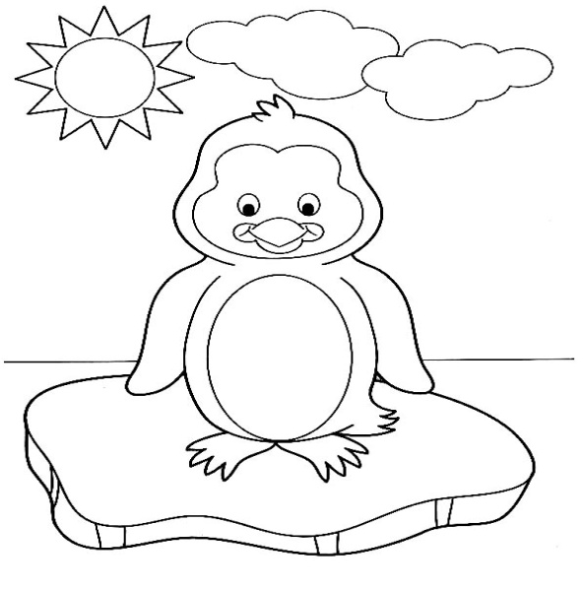
Room 206 Goodbye Party
Wednesday June 10th
11:45-12:30
Please join us for some end-of-year fun, a photo montage and popsicles on the playground.
Everyone on the cleared list is invited.
*This is not the same as the All Kindergarten party on June 11th

