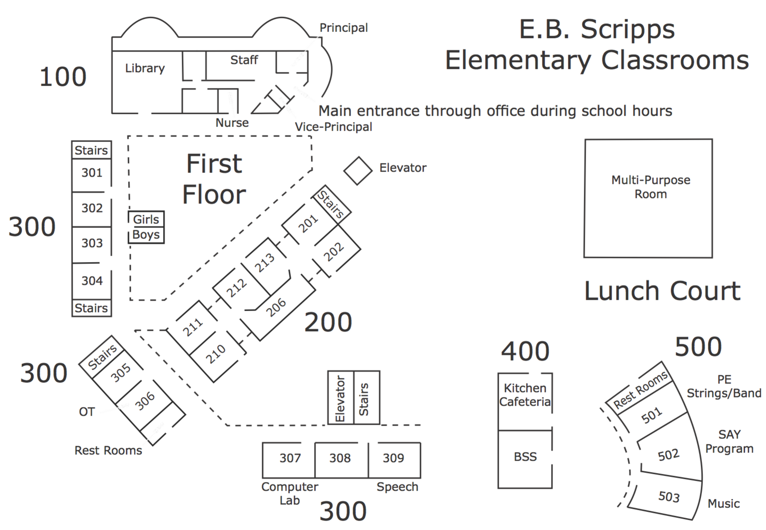

**206 Backpack Hooks**

ClaCd

**206 Classroom**

ClaCd